**DECIMAL TO BINARY CONVERSION**

**EXP NO: 25**

**AIM:** To write a C program to implement decimal to binary conversion.

**ALGORITHM:**  
1) Check if your number is odd or even.  
2)  If it's even, write 0 (proceeding backwards, adding binary digits to the left of the result).   
3)   Otherwise, if it's odd, write 1 (in the same way).  
4)   Divide your number by 2 (dropping any fraction) and go back to step 1. Repeat until your original number is 0.

**PROGRAM:**

#include<stdio.h>     
#include<stdlib.h>   
int main()  
{   
int a[10], n , i ;     
printf("Enter the number to convert: ");     
scanf("%d",&n);     
for(i=0;n>0;i++)     
{     
a[i]=n%2;     
n=n/2;     
}     
printf("\n Binary of Given Number is=");     
for(i=i-1;i>=0;i--)     
{     
printf("%d",a[i]);     
}     
return 0;   
}  
  
  
**INPUT:**  
  
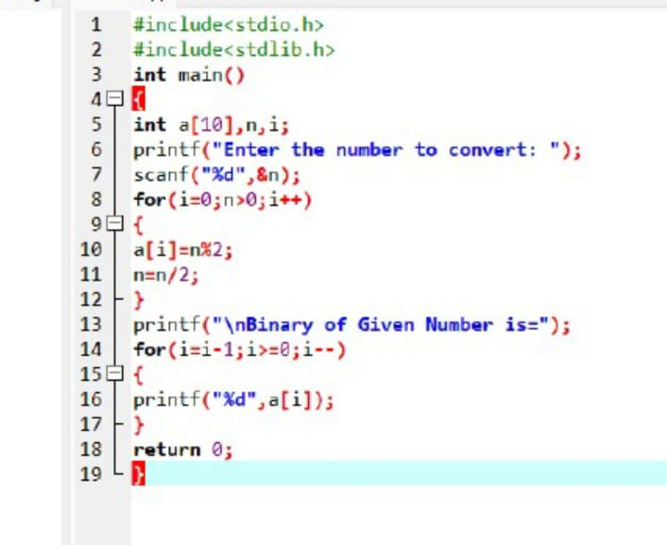  
  
  
**OUTPUT:**

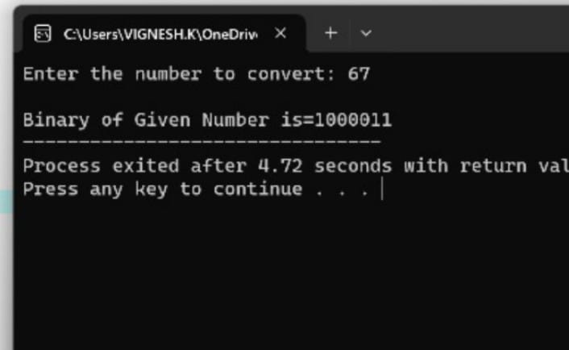  
  
  
  
  
  
  
  
  
  
  
  
  
  
  
**RESULT:**Thus the program was executed successfully using Dev C++.